# Shark Motion Waves and Warp Field Oscillations: A Comparative Model

This document illustrates how the wave motion of a shark swimming through water can be modeled mathematically and how the same principles of oscillatory motion and vortex formation can inform the design of warp-field bubbles. Both involve traveling waves, energy-efficient motion, and resonant frequencies that minimize drag or instability.

## 1. Shark Motion and Vortex Wake

A shark propels itself by generating a traveling sinusoidal wave along its body and tail. This produces alternating vortex rings in the water, which generate thrust. The efficiency of this motion is described by the Strouhal number St = fA/U, which most fast swimmers keep between 0.25 and 0.35 for maximum efficiency.

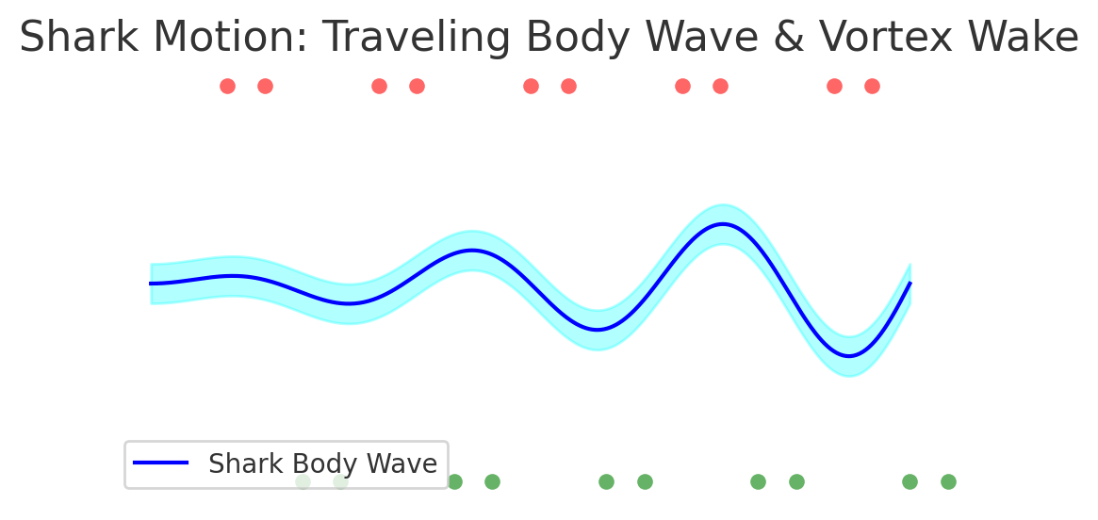

Figure 1. Shark body wave and vortex wake pattern (blue line = body wave; red/green dots = vortex rings).

## 2. Warp Field Bubble Oscillations

A warp drive bubble may achieve efficient spacetime curvature manipulation by oscillating its boundary similarly to a shark’s body wave. Instead of water vortices, the warp bubble would manage spacetime or field vortices. Matching the oscillation frequency to an optimal range (analogous to the Strouhal range) could minimize energy while maximizing stability.

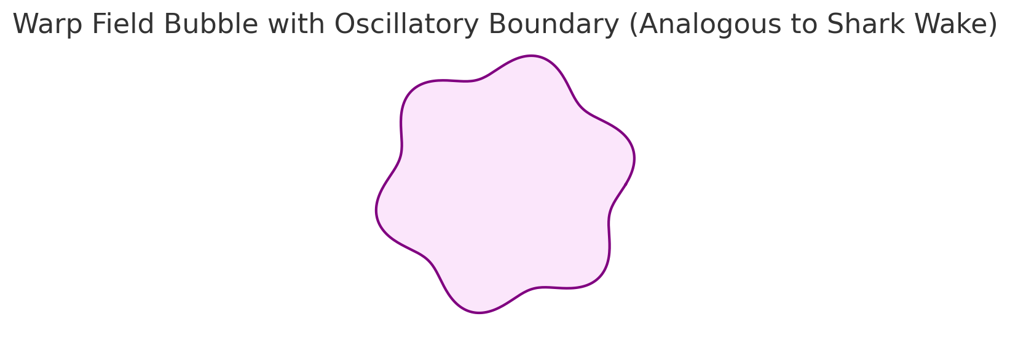

Figure 2. Oscillatory warp bubble boundary, analogous to a shark’s wave-driven propulsion in fluid.

## 3. Key Equations

Shark body wave:  
 y(x, t) = A(x) sin(kx - ωt)  
  
Thrust estimate:  
 T ≈ 2π²ρf²A²L  
  
Efficiency range (Strouhal number):  
 St = fA/U ≈ 0.25–0.35  
  
Warp bubble oscillation (conceptual):  
 r(θ, t) = R₀ + ε sin(nθ - ωt)  
  
where R₀ = average radius, ε = oscillation amplitude, n = mode number, ω = angular frequency.

By analyzing and tuning warp-bubble oscillations as if they were shark body waves in spacetime, one can target the most energy-efficient and stable corridor for faster-than-light travel.